=============================GIT=======================

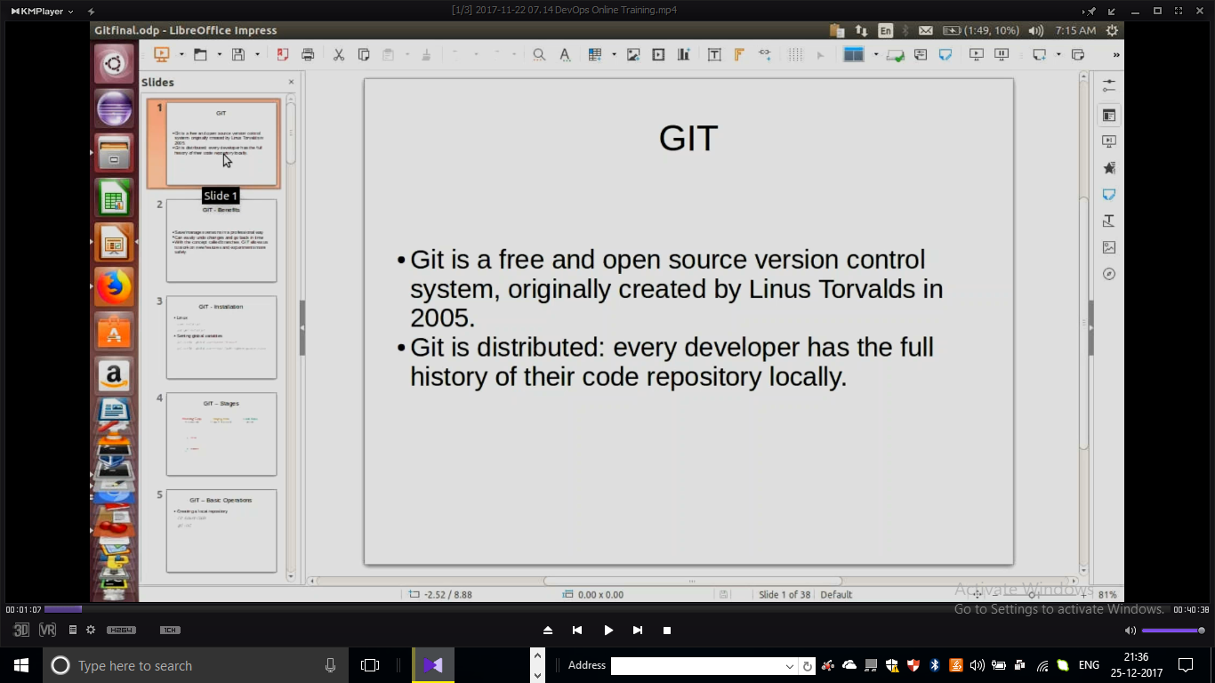

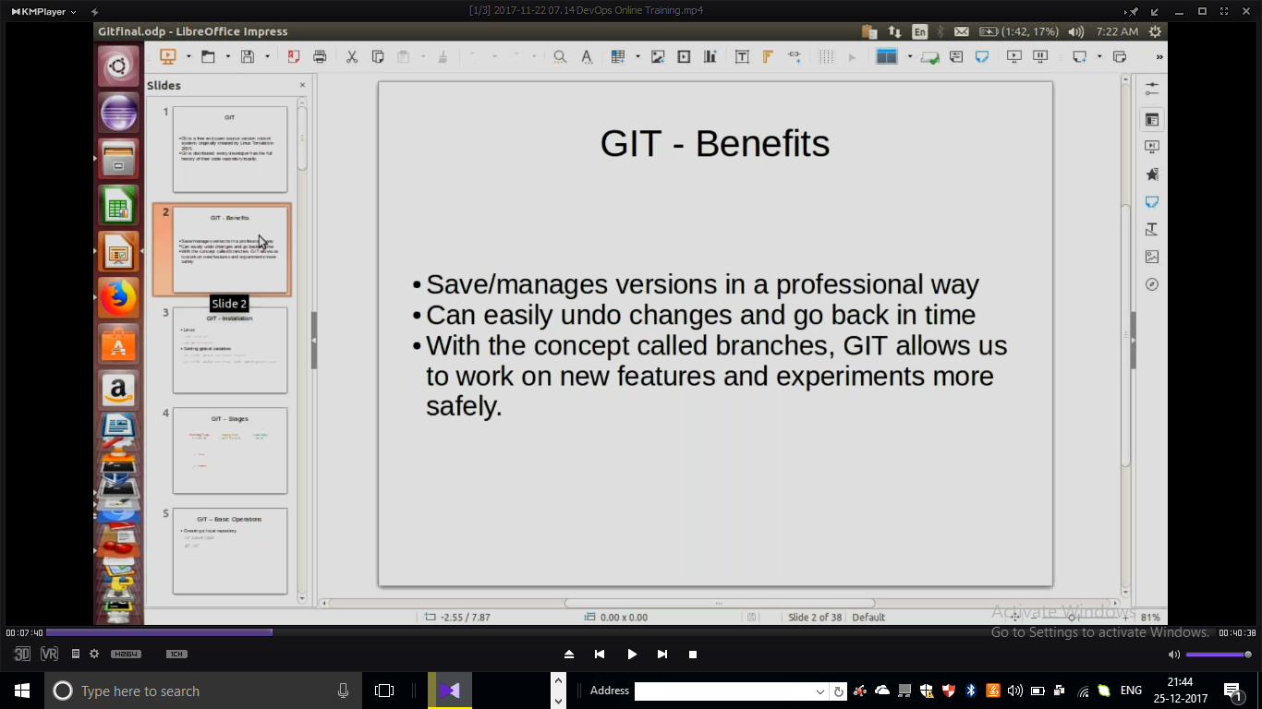

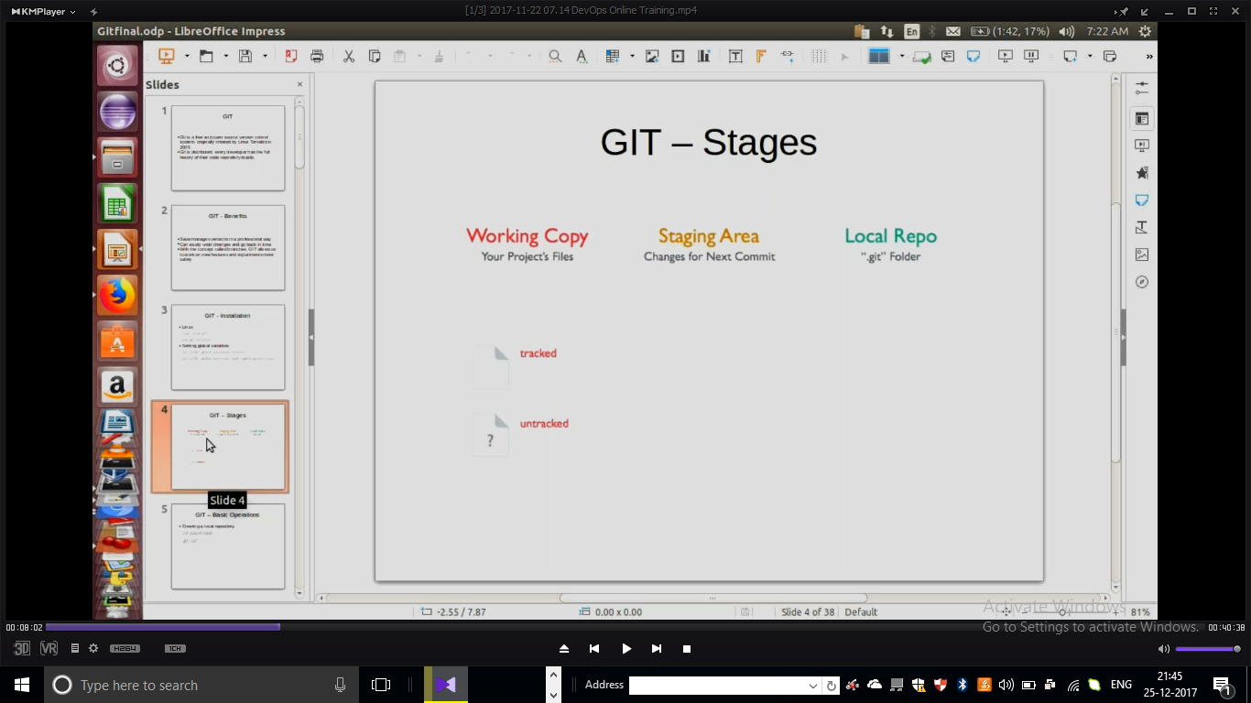

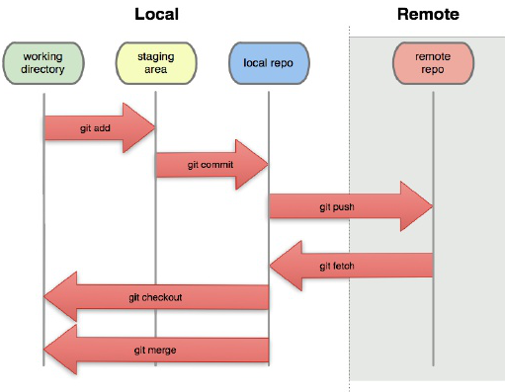

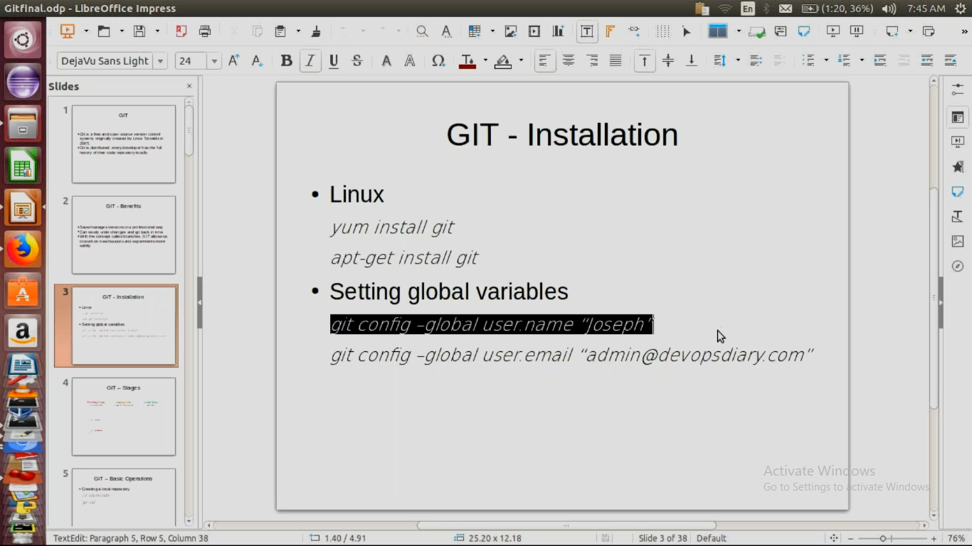

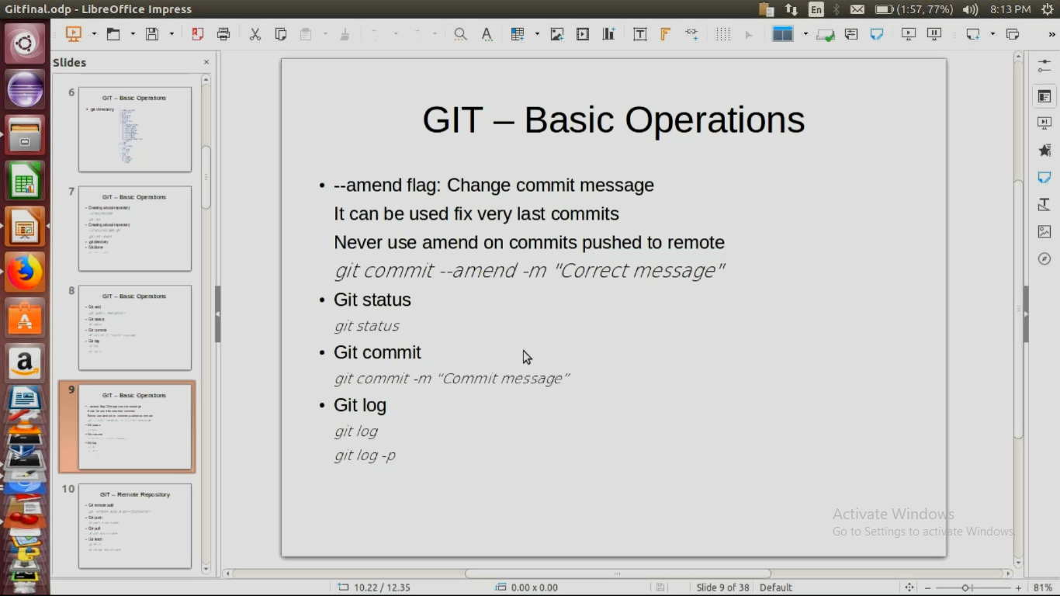

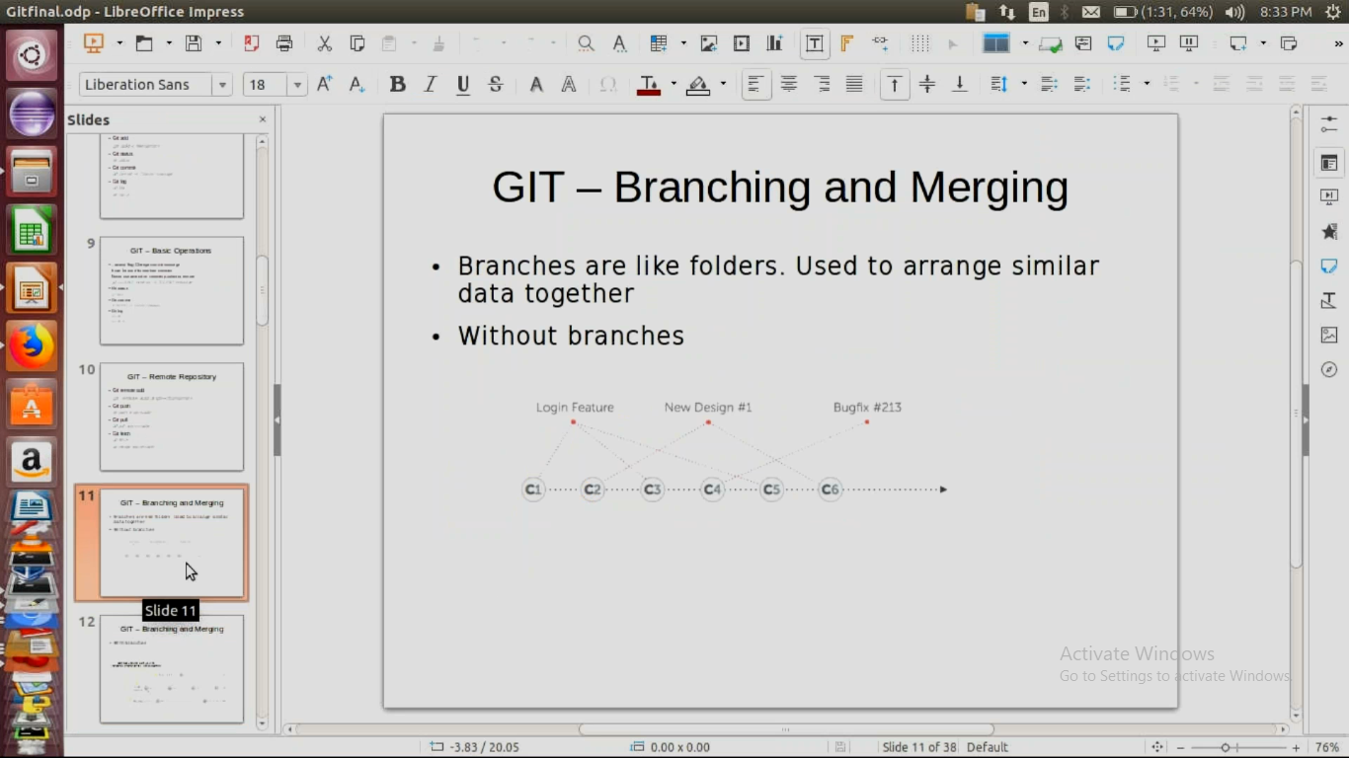

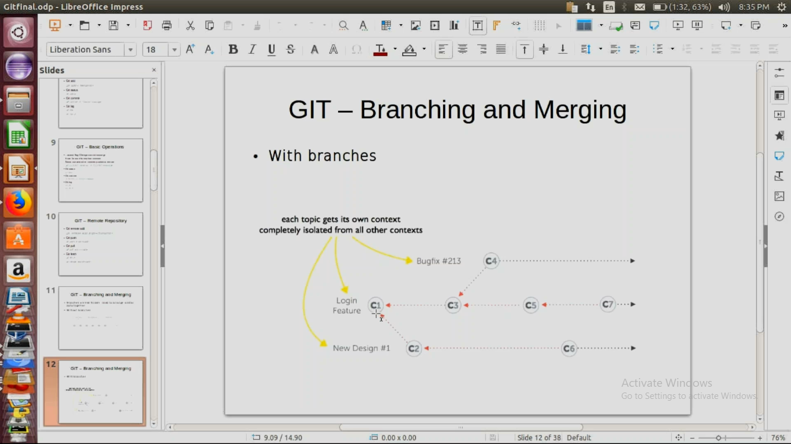

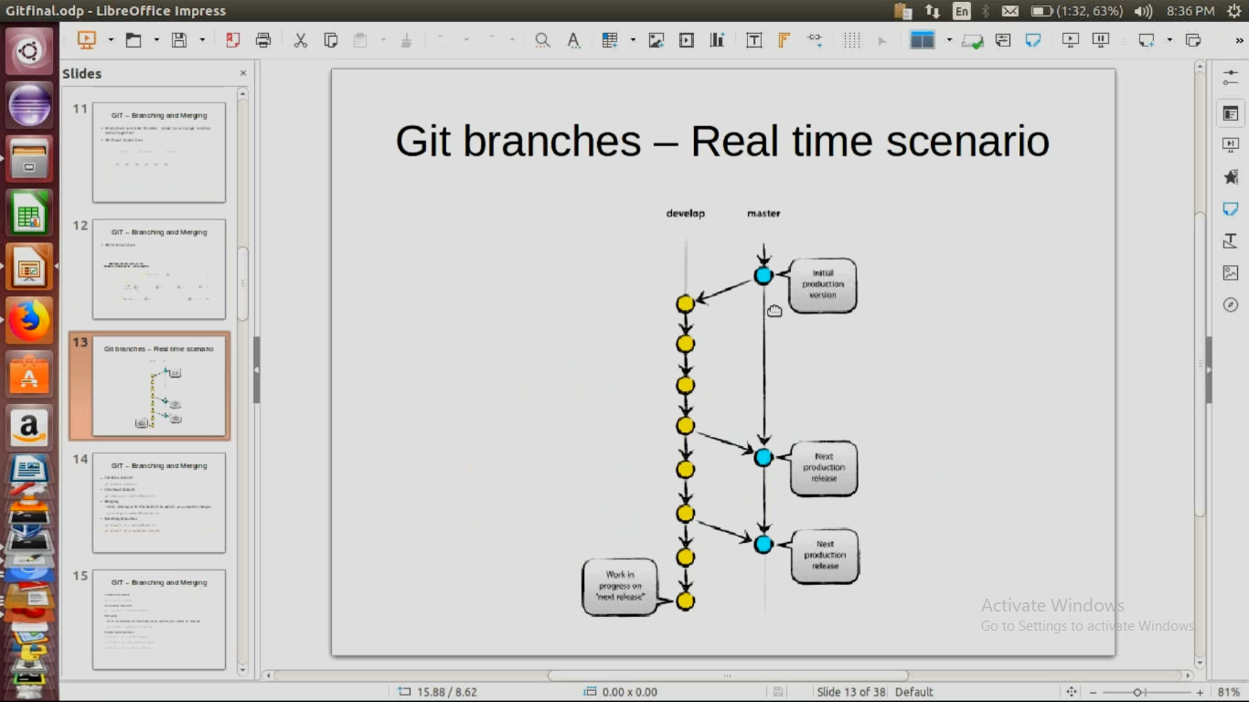

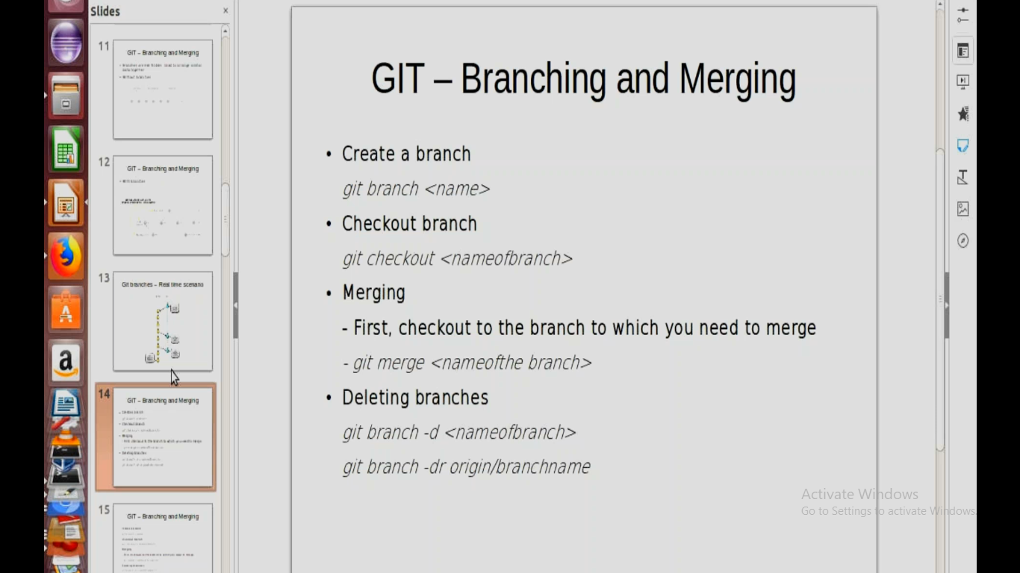

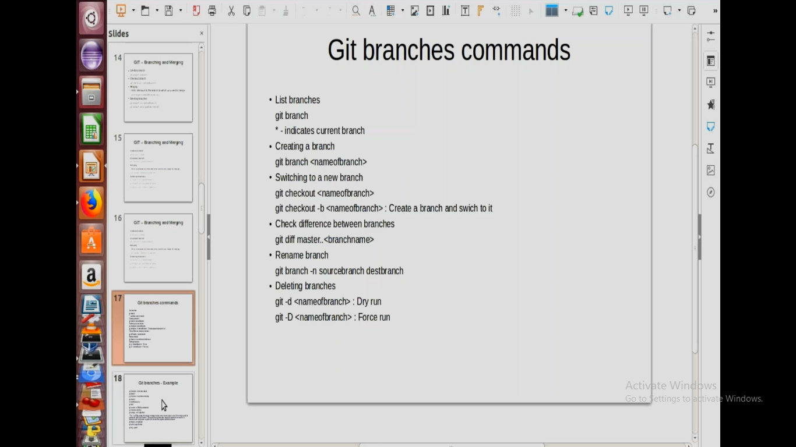

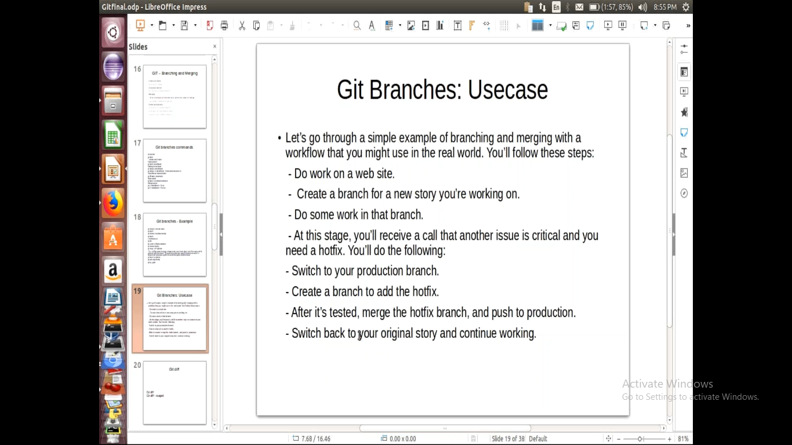

Git diff –staged

Git diff origin/master

Git diff origin/develop

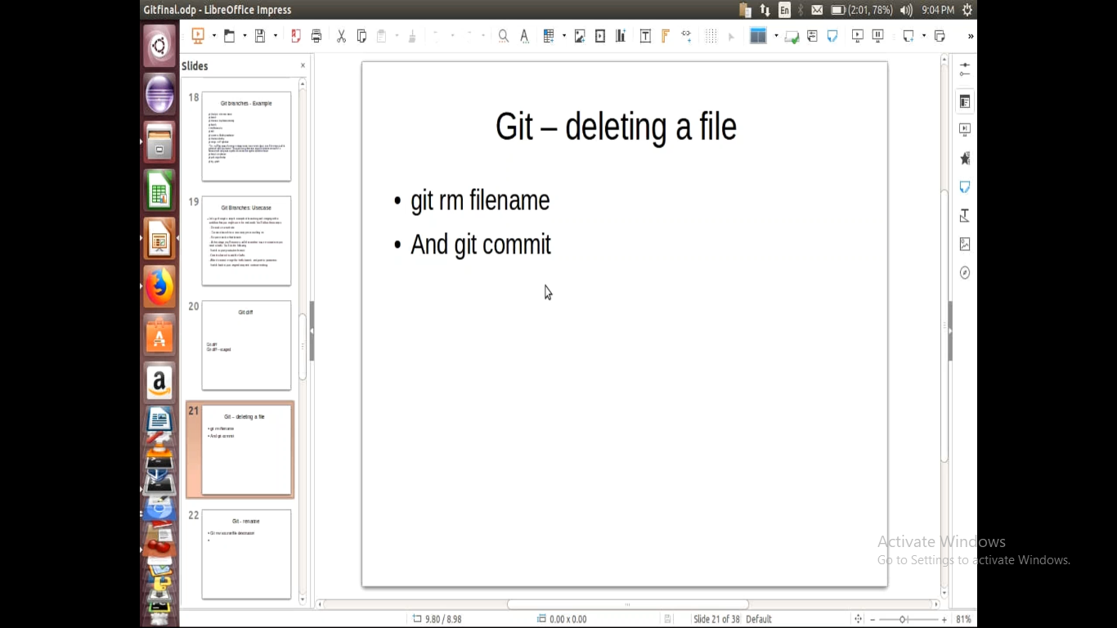

Rename :

Git mv oldfile newfile

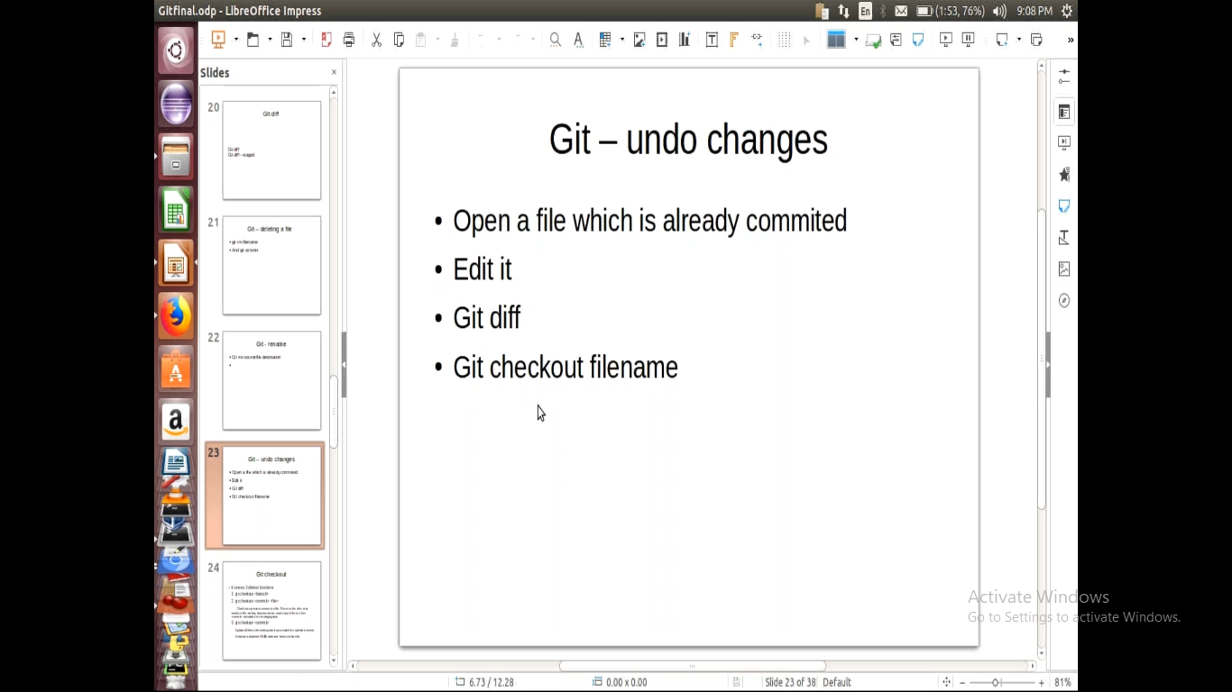

Git check filename -> it will undo to previous content file

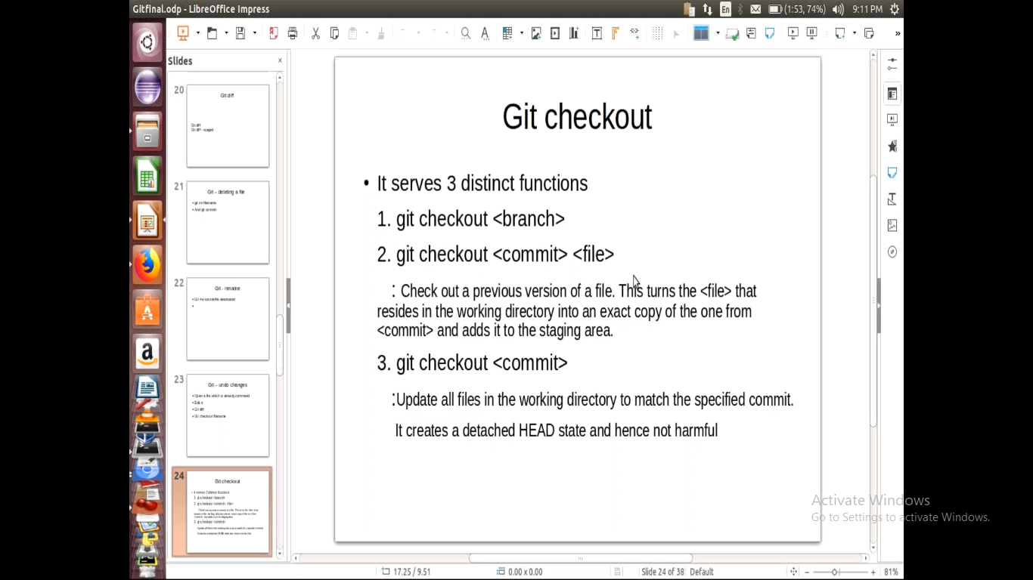

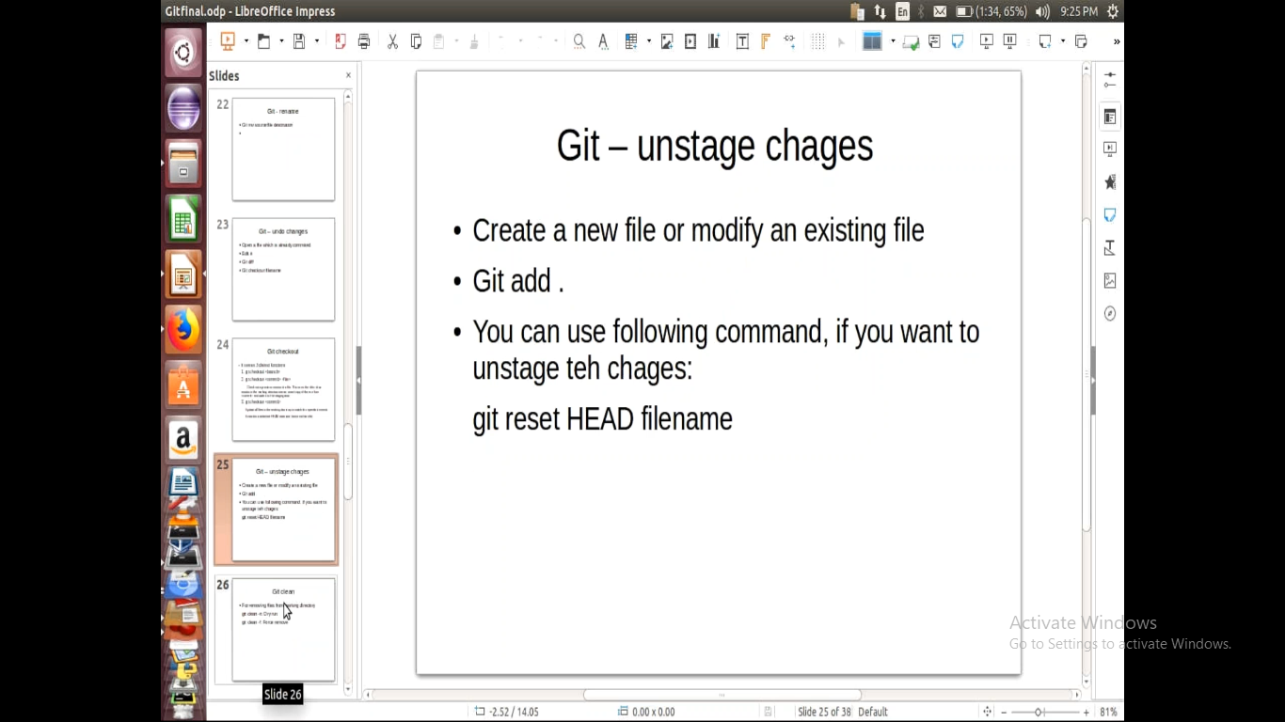

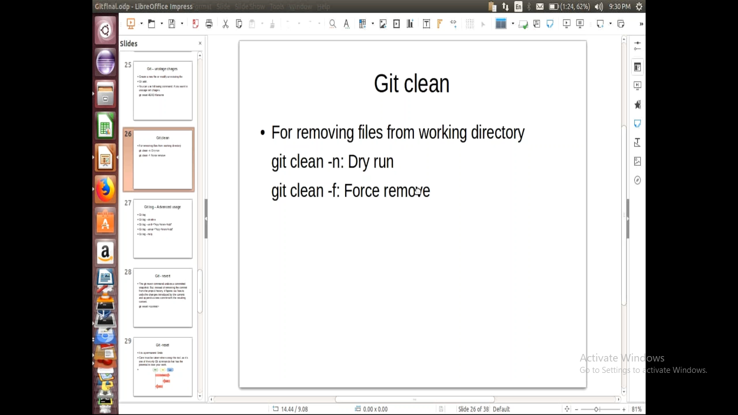

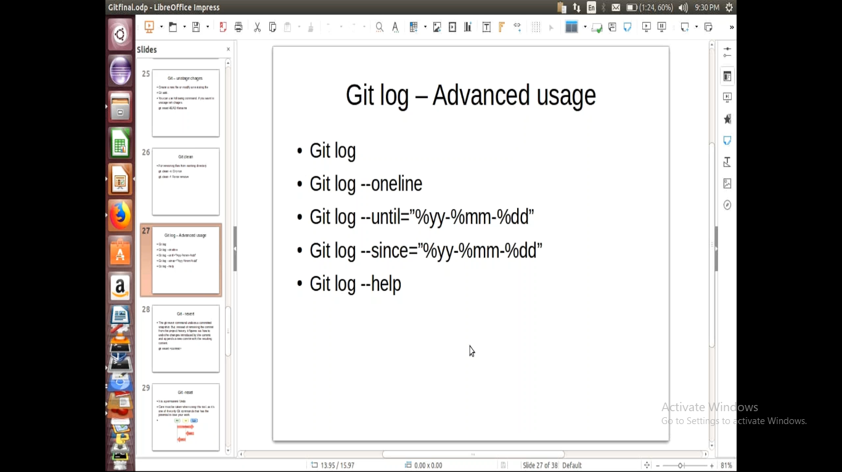

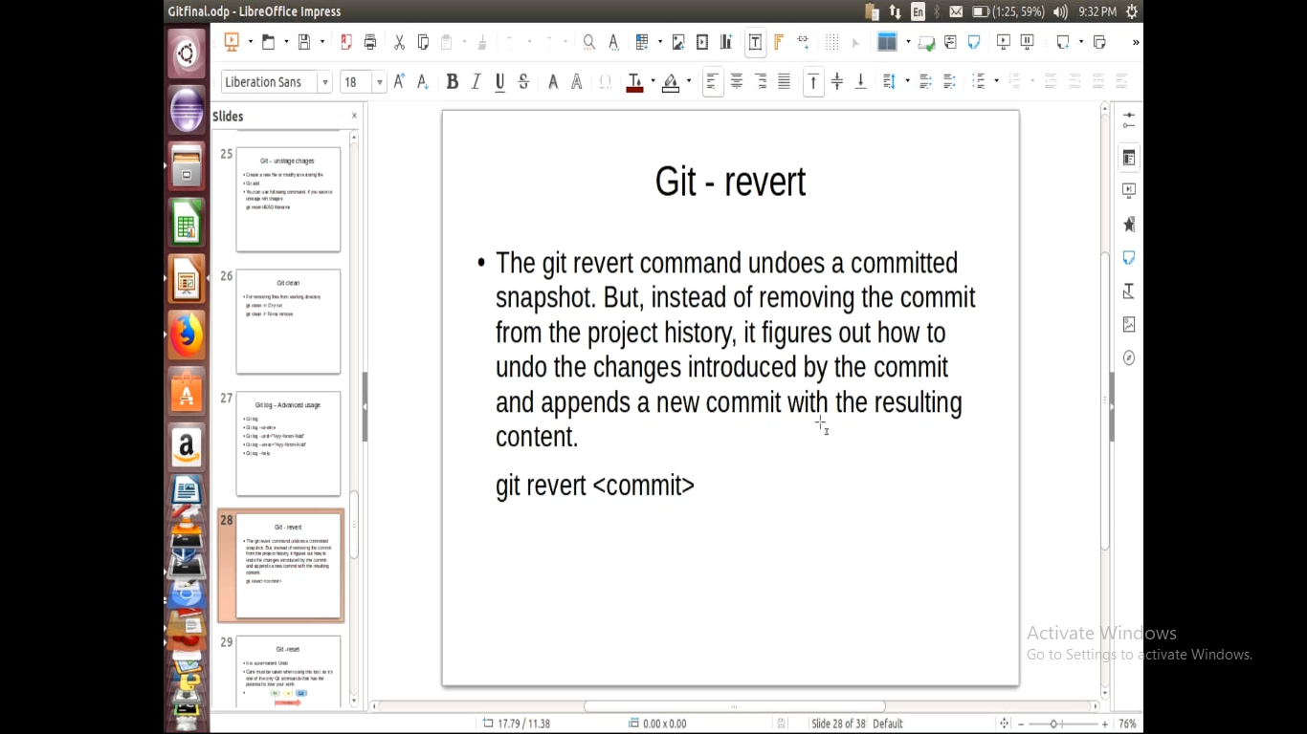

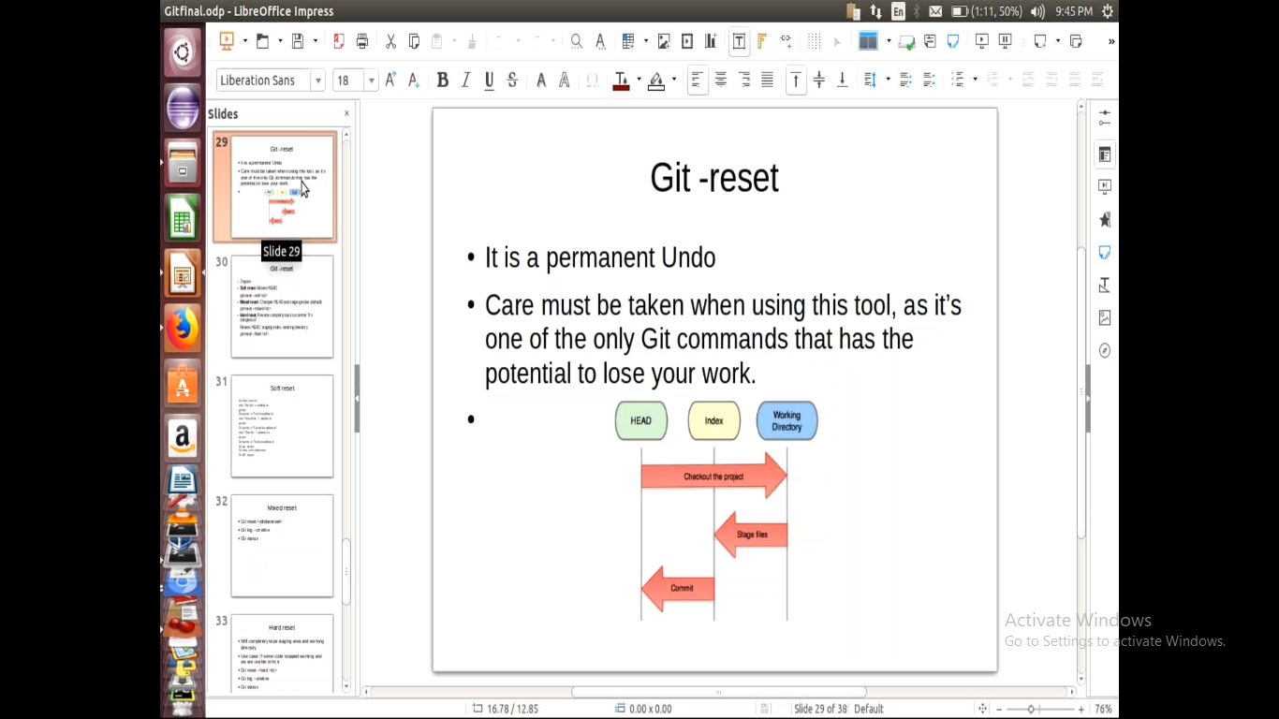

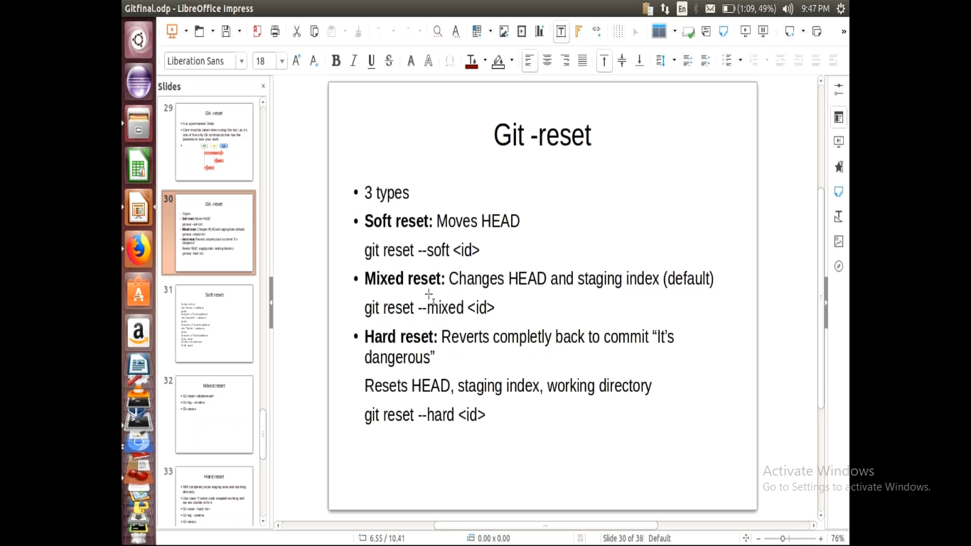

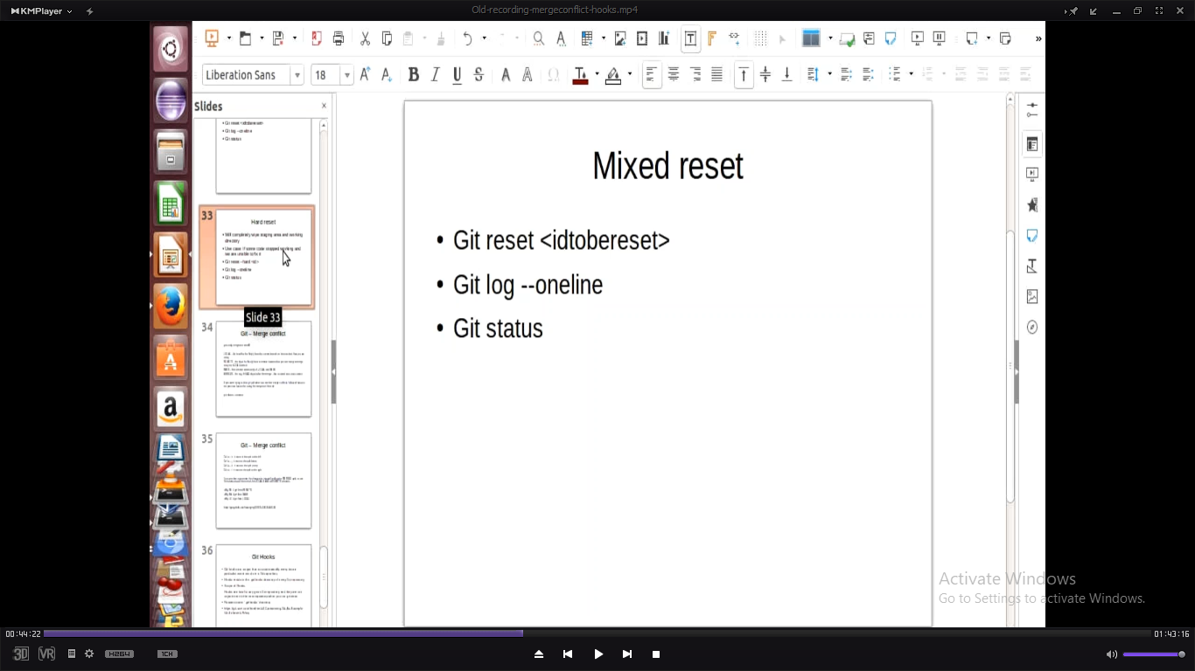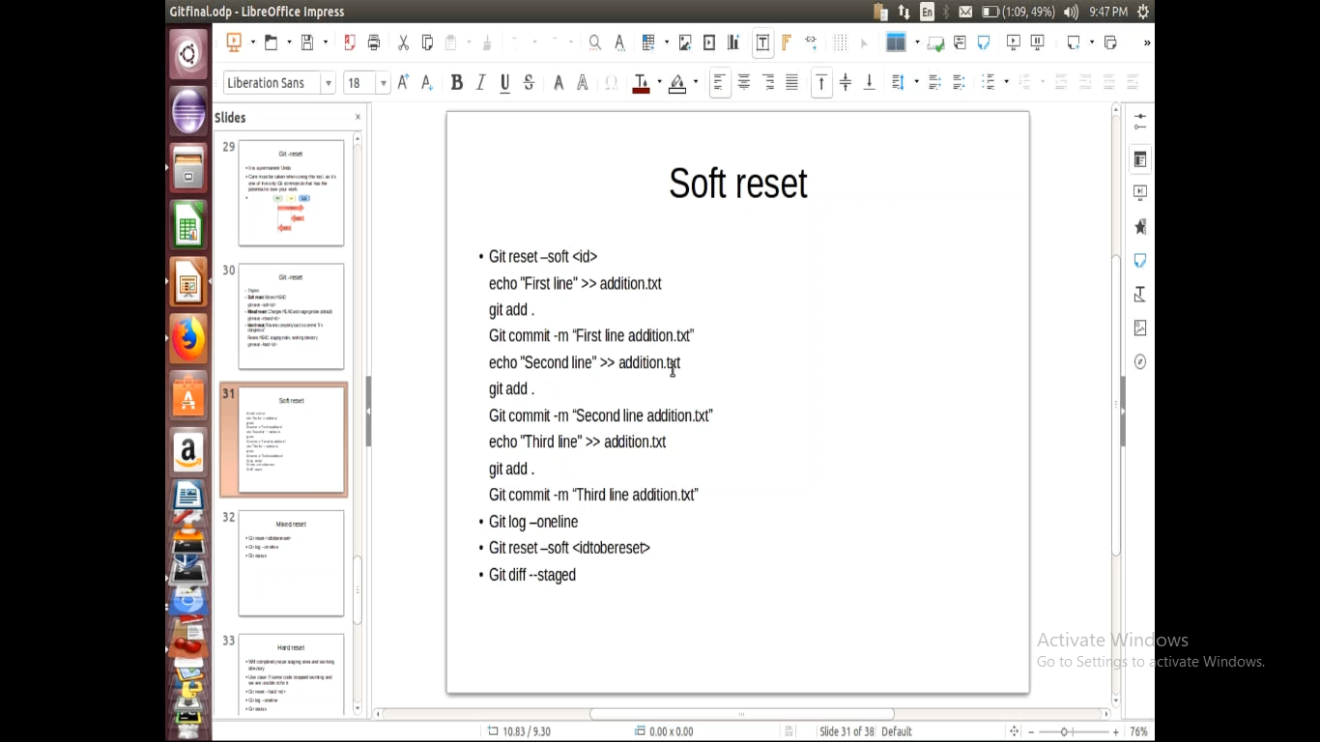

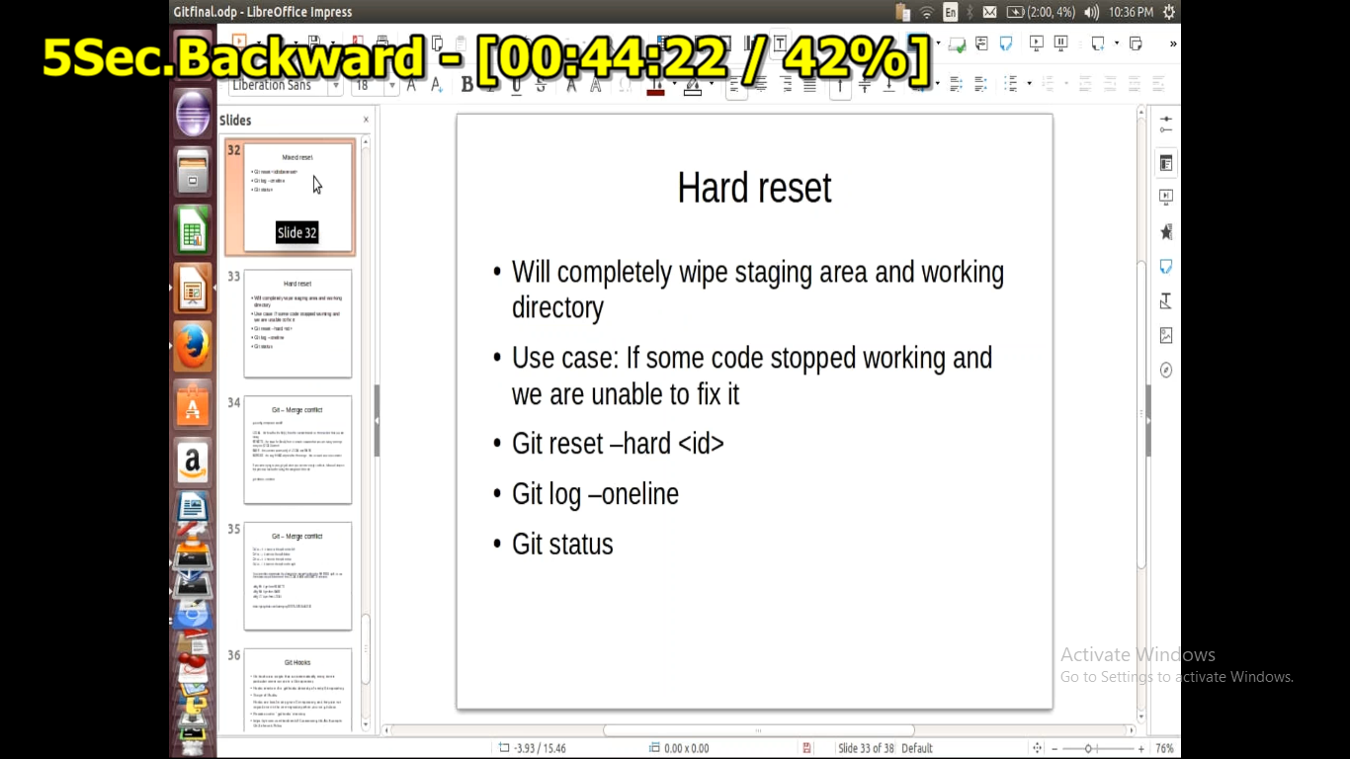

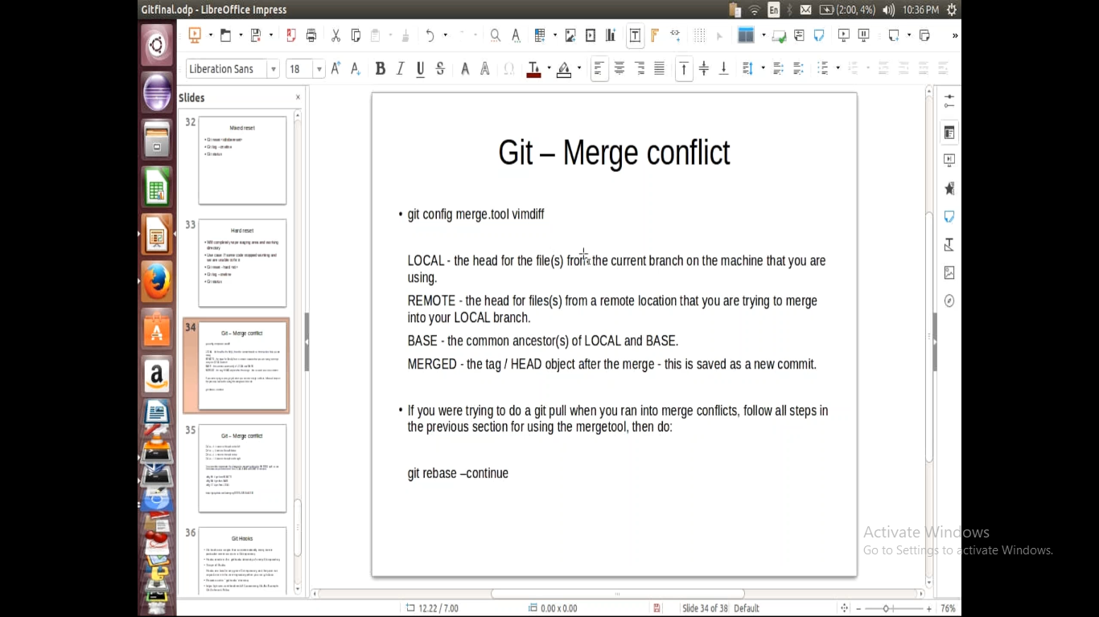

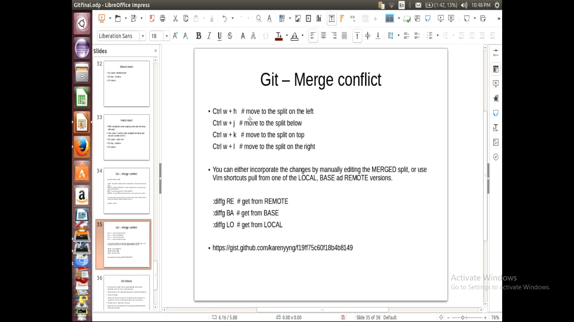

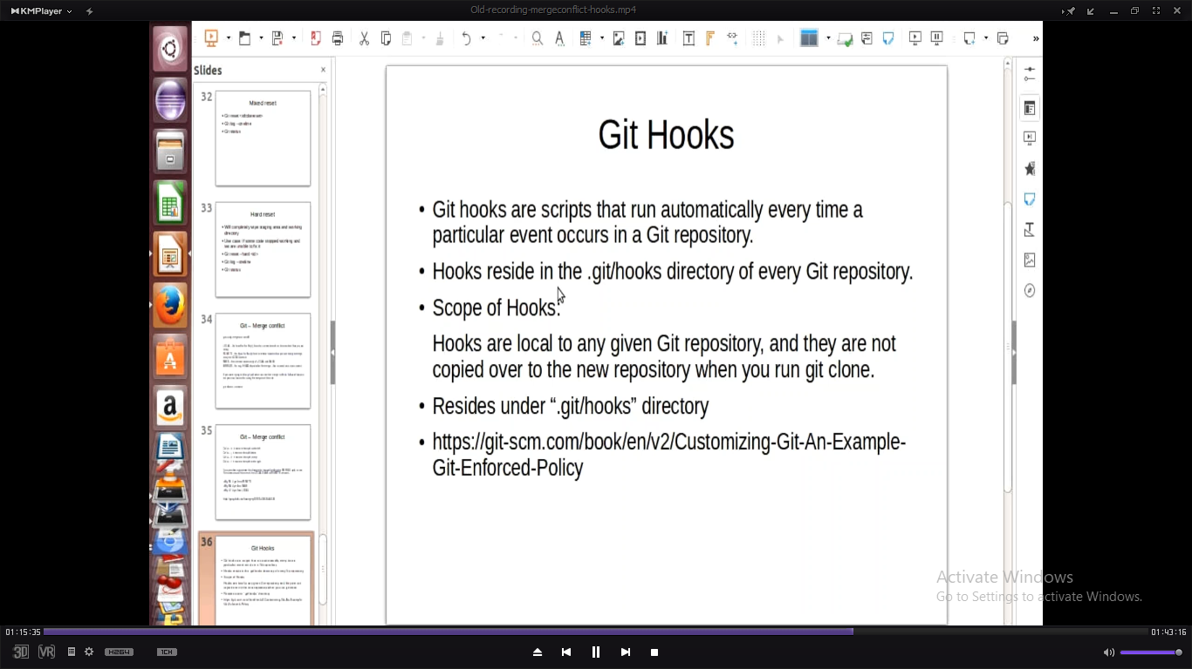

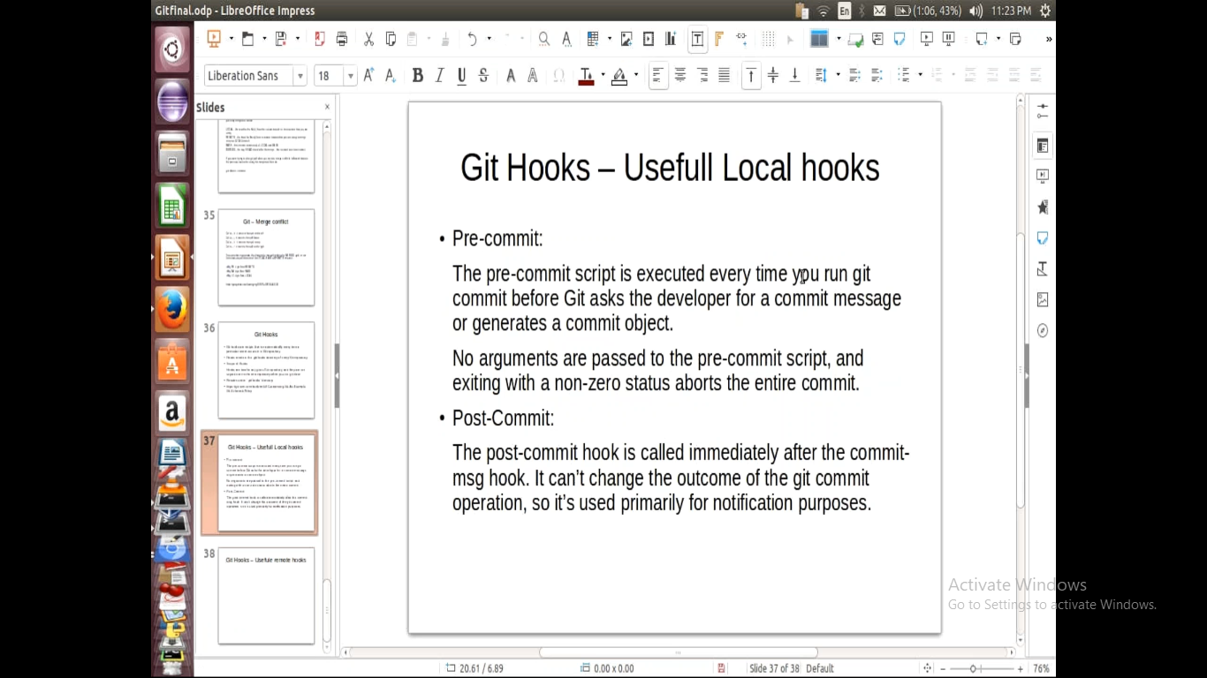

https://git-scm.com/book/en/v2/Customizing-Git-An-Examples

Steps to clone:

1. Create a remote repo
2. Now copy link of url
3. Open git bash and clone project

Git clone <url>

4)git add .

5)git commit –m “commit msg”

5)git push origin master

Git status -> we can see file status

Git add . (or) git add filename -> to add files

Git push origin master

Git pull origin master -> to pull code to local repo

Git log -> displays logs of “commited details”

Git log --oneline ->displayes short commit id and commit message

Git log –p -> displays entire history of commit history with file what changed

Git log –graph -> displays

Git status -> displays status of “git reposistory”

Git fetch -> it fetches files from remote repo for comparision purpose

Git diff origin master -> difference b/w local and remote repo data

Git merge origin master -> it will pulls from remote repo which are files are not in local repo

Git branch -> name of current wrking repo

Git branch <name of branch> -> it will create new branch

Git checkout <branch name> -> for shifting branches

Git branch –d <name of branch -> to delete branch